Internship Project Report

On

“ E-Learing platform ”
Submitted in the partial fulfillment of the requirement for the degree of

Bachelors of Technology

Submitted by

Kasa Siva Kumar Reddy
ID No: 21STUCRPN01010
VIII Semester, B.Tech. (CSE)

Under the Guidance of

Prof. DR. K. Kishore Kumar



The ICFAI University, Raipur
Faculty of Science & Technology
NH-53, Raipur-Bhilai Road, Km Stone: 20
: Kumhari, Dist: Durg 490042, Chhattisgarh
2024-2025

DECLARATION

I Kasa Siva Kumar Reddy, ID No:21STUCRPN01010 do hereby declare that this project report “E- Learing platform ” is being submitted to The ICFAI University, Raipur as a requirement of the subject Code – IP491 on date: 19th , may, 2025.
This is further to certify that, this project has been solely completed by me under the guidance and supervision of Prof. DR. K. Kishore Kumar , Faculty of Science and Technology of The ICFAI University, Purpul Technologies in Vijayawada,
I have worked on this project from 20/01/ 2025 to 30/ 05/2025 in the P urpul technology Technologies.

Signature
Date: Kasa Siva Kumar reddy

CERTIFICATE
This is to certify that the dissertation entitled

“E-Learing platform”
is a bonafide work and it is submitted to the The ICFAI University, Raipur To

Mr. KASA SIVAKUMAR REDDY , ID No:21STUCRPN01010
in the partial fulfillment of the requirement for the degree of Bachelors of Technology, during the academic year 2024-2025. This work has been carried out by the student under our guidance and supervision.
This is further to certify that the work detailed in the report is the outcome of the study performed by the student from 10th , january, 2025 to 10th may , 2025.

Prof. DR. K. Kishor Kumar Dr. Animesh Kumar
Sharma
University Guide
HOD


The ICFAI University, Raipur Faculty of Science & Technology
NH-53, Raipur-Bhilai Road, Km Stone: 20

PO: Kumhari, Dist: Durg 490042, Chhattisgarh

ACKNOWLEDGEMENT

I offer my gratitude and it’s my privilege to acknowledge indebtedness to my esteemed guide Prof. DR. K, Kishore kumar for his constant encouragement and noble guidance, without which this work would never been completed. Once again I express my sincere thanks for his valuable suggestion and encouragement.
I also express my thanks towards Dr. Animesh Kumar Sharma, HOD for his constant encouragement and noble guidance.
I express my deepest gratitude towards Dr. Kishore Kumar, Dean -Academics and all the teaching staff who helped me in this mission to finish the task successfully.

KASA Siva Kumar Reddy
ID No: 21STUCRPN01010 VIII Semester, B.Tech.

 | List if figures
Figures no | Title
1.1 | Homepage layout design
1.2 | Homepage layout
1.3 | Homepage Layout Design Showing Header
2.1 | User login interface
2.2 | User Login Interface with Secure Input Fields and Submit Button
2.3 | Login interface
3.1 | Registration Form with Name, Email, Password, and User Role Selection
3.2 | Registration form
4.1 | Course Playlist View with Thumbnails and Progress Indicators
4.2 | Contact form
4.4.3 | Course playlist view
4.4 | Course view
5.1 | User profile page design
5.2 | Profile Page Layout Featuring User Information
5.3 | Contact form
6.1 | About page with images
6.2 | Responsive navigation bar
7.1 | Navigation bar
7.1 | Responsive Navigation Bar for Mobile and Desktop Devices
7.3 | Footer design
8.1 | CSS styling examples
8.2 | CSS styling illustration
9.1 | Project folder structure overview
9.2 | Summary of All Interface Pages Displayed in Tabbed Preview Format

Chapters | Contents | Page no.
 | Declaration
 | Certificate
 | Acknowledgement
 | List of Figure
 | List of Table
Chapter 1 | Introducton (E-Learing platform)
1.1 | Background & Motivation
1.2 | Project Objectives
1.3 | Scope & Deliverables
1.4 | Document Organization
Chapter 2 | Stakeholder Interviews & User Personas
2.1 | Stakeholder Interviews
2.2 | Functional Requirements
2.3 | Non-functional Requirements
2.4 | Technology Stack Selection
Chapter 3 | Information Architecture & UX Design
3.1 | Site Map & Content Inventory
3.2 | Wireframes & Prototypes
3.3 | User Flow Diagrams
3.4 | Usability Testing Plan
Chapter 4 | Visual Design & Style Guide
4.1 | Branding Guidelines
4.2 | Component Library Overview
4.3 | Responsive Design Breakpoints
4.4 | Accessibility Considerations
Chapter 5 | CSS Stylesheet Architecture
5.1 | Folder Structure & Naming Conventions
5.2 | Use of Preprocessors or Methodologies
5.3 | Core Variables & Mixins
5.4 | Utility & Layout Classes
Chapter 6 | Front-End Implementation
6.1 | HTML Structure & Semantic Markup
6.2 | CSS Integration & Build Pipeline
6.3 | JavaScript Enhancements
6.4 | Cross-Browser Testing
Chapter 7 | Quality Assurance & Testing
7.1 | Test Cases & Procedures
7.2 | Automated Testing Tools
7.3 | Accessibility Audits
7.4 | Performance Optimization Results
Chapter 8 | Deployment & Maintenance
8.1 | Hosting Environment & CI/CD Setup
8.2 | Version Control Practices
8.3 | Backup & Rollback Strategies
8.4 | Ongoing Maintenance Plan
Chapter 9 | Results & Evaluati
9.1 | Key Performance Indicators
9.2 | Stakeholder Feedback
9.3 | Lessons Learned
Chapter 10 | Conclusion & Future Work
10.1 | Summary of Achievements
10.2 | Potential Enhancements
10.3 | Final Thoughts
Chapter 11 | Conclusion
 | reference
 | Offer letter
 | Certificate of completion

CHAPTER 1

INTRODUCTION

1.1 Background & Motivation
The web has evolved from a simple collection of hyperlinked documents into a complex ecosystem of interactive applications, dynamic content, and rich media experiences. What began as static HTML pages has given way to responsive layouts, fluid grids, and sophisticated user interfaces powered by JavaScript frameworks. Amid this rapid transformation, Cascading Style Sheets (CSS) has remained the backbone of presentation and layout on the web. Yet as projects grow in scope and teams expand, unstructured or ad-hoc CSS often morphs into a tangled web of overrides, id selectors, and specificity wars—making even small changes laborious and error-prone.
Our project originated from firsthand experiences with large-scale front-end codebases in both agency and enterprise settings. In these environments, teams of designers and developers work in parallel: designers iterate on mockups in Sketch or Figma, while developers translate those designs into living code. Without a shared language or clear conventions, translation errors creep in. Color values diverge, typography scales drift, and edge-case layouts break. The result? A widening gap between the envisioned design system and the implemented product—slowdowns in development velocity, mounting technical debt, and frustrated stakeholders.
To address these challenges, we turned to CSS architecture methodologies—specifically BEM (Block, Element, Modifier) and SMACSS (Scalable and Modular Architecture for CSS). These methodologies prescribe naming conventions, file organization patterns, and principles for modularity. Simultaneously, advances in build tooling—Sass for preprocessing, PostCSS for transformations, and CSSNano for minification—offer opportunities to automate repetitive tasks, enforce consistency, and optimize output for performance. Our motivation was to marry these methodologies and tools into a cohesive, repeatable process that any team could adopt, regardless of size or technology stack.
By formalizing a flexible stylesheet architecture, we aim to achieve three key benefits:
- Maintainability
A predictable folder structure and naming convention reduce cognitive overhead when locating or updating styles. Developers spend less time hunting down overrides and more time building features.
- Cross-Functional
A shared component library—documented with clear usage examples—bridges the gap between design and development. New team members onboard quickly, knowing exactly where to find and how to contribute to visual patterns.
- Performance
Through build-time optimizations and critical-path CSS extraction, we minimize render-bloc
1.2 Project Objectives
Building on this motivation, the project sets forth the following objectives:
- Define a Scalable CSS Framework
  - Folder Structure: Establish clear directories (e.g., base/, layout/, components/, utilities/), guided by SMACSS categories.
  - Naming Conventions: Adopt a BEM-inspired syntax to avoid selector collisions and enable component isolation
  - Modularity: Ensure every component’s styles encapsulate its own variables, Mixins, and overrides

- Streamline Development Workflow
  - Preprocessing: Leverage Sass to create variables for color palettes, typography scales, and spacing units; implement mixins for media queries and vendor prefixes.
  - Automation: Integrate Stylelint in the CI pipeline to enforce code style; set up npm scripts or Gulp tasks for linting, compilation, and minification.
  - Documentation: Generate living style guides (using tools like Storybook or KSS) that auto-sync with the codebase, ensuring documentation never drifts from implementation.
- Guarantee Consistent Design Language
  - Design Tokens: Centralize core tokens—colors, font sizes, border radii—so adjustments propagate across every component.
  - Component Library: Build a catalog of reusable UI elements (buttons, cards, forms) with usage examples and variant descriptions.
  - Theming: Enable light/dark or brand-specific themes through CSS custom properties, toggleable at runtime.
- Embed Performance and Accessibility
  - Critical-Path CSS: Extract above-the-fold styles into inline blocks for faster First Paint metrics.
  - Lazy-Load Styles: Defer non-critical CSS to later stages of page load or on demand
- Accessibility Compliance: Integrate Color contrast checks, keyboard navigation patterns, and screen-reader announcements directly into component code and documentation.
1.3 Scope & Deliverables
Scope: This project concentrates exclusively on the CSS architecture and its integration into a standard front-end workflow. While we touch on HTML semantics, JavaScript enhancements, and deployment practices, the lion’s share of effort focuses on how styles are structured, authored, and maintained.
Key Deliverables:
Deliverable | Description
Requirements& Analysis Report | Living documentation with tokens, component specs, and usage guidelines
Style Guide & Design System | Folder layout diagrams, naming convention rules, and methodology primer
Stylesheet Architecture Blueprint | Sample gulpfile.js or npm scripts; Sass and PostCSS configs; linting rules
Build Configuration Files | HTML prototypes showcasing core components in action—navigation, forms, modals, etc.
Sample Integration Pages | Results from accessibility (axe, Lighthouse) and performance testing tools
Testing&Audit Reports | Best practices for adding new components, updating tokens, and running CI checks
Maintenance & Onboarding Guide | Together, these artifacts form an end-to-end solution: from planning through deployment, with built-in processes for evolution and handoff.

1.4 Document Organization
To navigate this documentation effectively, here is the chapter breakdown:
- Introduction (this chapter): Context, objectives, scope, and organization.
- Requirements Analysis: Stakeholder interviews, user personas, and detailed functional/non-functional requirements.
- Information Architecture & UX Design: Site maps, wireframes, user flows, and prototyping strategies.
- Visual Design & Style Guide: Branding assets, typography scales, color palettes, and responsive design guidelines.
- CSS Stylesheet Architecture: Folder structures, naming conventions, methodology deep-dive (BEM/SMACSS), design tokens, and mixins.
- Front-End Implementation: Integrating styles into HTML pages, build pipelines, and JavaScript enhancements.
- Quality Assurance & Testing: Linting, unit tests, accessibility audits, and performance optimization techniques.
- Deployment & Maintenance: CI/CD pipelines, version control workflows, rollback strategies, and long-term upkeep.
- Results & Evaluation: Key performance indicators, audit metrics, and stakeholder feedback.
- Conclusion & Future Work: Summary of achievements, lessons learned, and a roadmap for enhancements.
Each chapter builds on the previous one, but you can also reference individual sections as needed. Appendices at the end provide code snippets, test checklists, and a glossary of terms for quick reference.

CHAPTER 2

Stakeholder Interviews & User Personas

2.1 Stakeholder Interviews & User Personas
Effective design begins with a clear understanding of who will use the website and what they need. To ground our approach in real-world goals, we conducted interviews with four key stakeholder groups:
- Marketing Team
  - Goals: Increase brand awareness, drive newsletter sign-ups, and promote new products.
  - Pain Points: Difficulty tracking conversions across disparate pages; inconsistent styling that dilutes brand messaging.
  - Desires: A clear, on-brand design system that reinforces campaign calls to action.
- Product Managers
  - Goals: Rapidly prototype new features; collect user feedback for iterative improvements.
  - Pain Points: Slow front-end turnaround times; merging custom styles into an unruly CSS codebase.
  - Desires: A modular component library enabling drag-and-drop page composition without styling regressions.
- End Users (Prospective Customers)
  - Goals: Discover product information quickly; compare features; complete purchases with minimal friction.
  - Pain Points: Overwhelming navigation; inconsistent layouts that make it hard to locate key details.
  - Desires: A clean, predictable interface that behaves consistently across pages and devices.
- Customer Support Representatives
  - Goals: Access up-to-date documentation; point users to the correct help topics; minimize support tickets.
  - Pain Points: Confusing UI updates that break help-center links; lack of centralized style guidelines.
  - Desires: A unified look and feel across the website and help portal to streamline user guidance.
From these interviews we distilled three user personas to guide our design:

- “Alex the Explorer”
  - Tech-savvy, browses on desktop and mobile interchangeably, values quick access to feature comparisons.
- “Bailey the Browser”
  - Research-oriented, often has accessibility needs (large font sizes, high-contrast color schemes).
- “Casey the Casual Visitor”
  - First-time visitor, impatient with load times, likely to abandon if the page feels slow or cluttered.
Each persona informed our functional and non-functional requirements, ensuring that we built not only for business goals but also for real user needs.

2.2 Functional Requirements
Based on stakeholder and persona analysis, the following core functionalities must be supported:
- Responsive Navigation
  - A multi-level menu that adapts to desktop and mobile, collapsible on small viewports.
  - Keyboard and screen-reader support for all menu items and submenus.
- Component Library
  - A catalog of reusable UI components (buttons, cards, modals, forms) with configurable variants (size, color, state).
  - Programmatic theming via CSS custom properties to allow on-the-fly appearance changes.
- Content Authoring Interface
  - A WYSIWYG page builder that leverages pre-designed components, ensuring authors cannot introduce unstyled elements.
  - Ability to preview content across breakpoints within the builder.
- Performance Monitoring Dashboard
  - Integration with tools like Google Lighthouse or WebPageTest to display metrics (First Contentful Paint, Time to Interactive) in an admin panel.
  - Alerts for regressions when CSS bundles exceed defined size thresholds.
- Accessibility Validation
  - Automated checks using axe-core or similar libraries during the build process.
  - Manual audit checklist for common issues (color contrast, focus management, ARIA roles).
- Theming & Brand Variations
  - Support for light and dark mode toggles.
  - Brand-specific overrides for white-label deployments without altering core styles.
- Content Modules & Templates
  - Predefined page templates (landing page, product detail, blog article) using modular sections that can be rearranged.
.

2.3 Non-functional Requirements
Beyond functionality, we must ensure the site meets key quality attributes:
Usability
- Consistency: Visual patterns and interactions should behave identically across pages.
- Learnability: New users can navigate to primary tasks (e.g., search, checkout) within two clicks.
- Error Prevention: Form validations with inline feedback; disabled submission buttons until required fields are valid.
Performance
- Load Time: “First Contentful Paint” under 1.5 seconds on mobile 3G; “Time to Interactive” under 3 seconds on modern desktop.
- Bundle Size: CSS bundle compressed under 100 KB; critical-path inlined CSS under 14 KB.
- Caching Strategy: Leverage HTTP caching with versioned file names; leverage service workers for repeat visits.
Accessibility
- Standards Compliance: WCAG 2.1 AA minimum across all public-facing pages.
- Keyboard Navigation: Focus order logical and visible; skip-to-content links available on every page.
- Screen Readers: Proper use of landmarks, ARIA roles, and live region alerts where dynamic content updates.
Maintainability
- Code Quality: Stylelint rules enforced in CI; no CSS linter warnings allowed on pull requests.
- Documentation: Auto-generated style guide updated with each merge; code comments for complex mixins and functions.
- Scalability: Architecture accommodates adding new components or themes without risking regressions.

2.4 Technology Stack Selection
To satisfy these requirements, we evaluated several tools and frameworks:

Category | Candidate | Rationale
Preprocessor | Sass | Mature ecosystem, supports variables, nesting, mixins
Post-processor | PostCSS + Autoprefixer | Automated vendor prefixes; plugin architecture
CSS Methodology | BEM + SMACSS | Clear naming conventions; modular categorization
Linting | Stylelint | Extensible rules; integrates with editors and CI
Build Tool | npm Scripts / Gulp | Simple task definitions; wide community support
Style Documentation | KSS / Storybook | Live documentation with code examples
Accessibility | axe-core + Pa11y CLI | Automated audits; CLI integration for CI
Performance | Lighthouse CI | Automated lab metrics; CI integration
Version Control | Git + GitHub | Pull-request workflow; protected branches

After prototype experiments, we selected Sass for preprocessing (due to its maturity and built-in control directives), PostCSS for post-processing and minification, and a combination of BEM and SMACSS for our methodology. Stylelint enforces conventions during development and CI, while Lighthouse CI and axe-core handle performance and accessibility checks. We’ll document components using Storybook, enabling live previews alongside code.

CHAPTER 3

Information Architecture & UX Design

3.1 Site Map & Content Inventory
A comprehensive site map establishes the hierarchical structure of all pages and major content groupings. We began by auditing existing pages and identifying primary content domains—Home, Product Catalog, Blog, Support, and Account Management. From there, we broke each domain into subpages and functional sections:
- Home
  - Hero banner
  - Featured products carousel
  - Testimonials
  - Newsletter signup
- Product Catalog
  - Category landing pages (e.g., “Electronics,” “Accessories”)
  - Product detail templates
  - Filtering and sort controls
- Blog
  - Article index
  - Category-specific feeds
  - Individual article pages with related content
- Support
  - Knowledge base home
  - Topic hubs (e.g., “Shipping,” “Returns”)
  - Step-by-step guides and FAQs
- Account Management
  - Profile overview
  - Order history
  - Address book and payment methods
Alongside the site map, we compiled a content inventory spreadsheet recording each URL, page purpose, content owner, and metadata status. This exercise revealed several orphaned pages and redundant templates, which we slated for consolidation. By cataloging every content asset—even down to sidebar callouts and footer links—we gained clarity on what to migrate, archive, or redesign.

3.2 Wireframes & Prototypes
With the site map defined, low-fidelity wireframes served as the first visual touchpoint. Key principles guided our wireframing:
- Mobile-first layout: Sketching on a narrow canvas (320px width) ensured core elements prioritize vertical flow and thumb-friendly touch targets.
- Grid consistency: We adopted a 12-column grid for desktop and a 4-column grid for tablets, maintaining proportional spacing and alignment.
- Component reuse: Wireframes reused atomic elements (buttons, inputs) rather than bespoke patterns, reinforcing modularity.
For each major template—Homepage, Category Page, Product Page, Blog Listing—we produced grayscale wireframes annotated with interaction notes (e.g., “on click, expand filter pane,” “lazy-load additional articles”). These wireframes were reviewed in design crit sessions with stakeholders, who flagged priorities (such as elevating the search bar on mobile and simplifying the checkout call-to-action).
Next, we translated approved wireframes into interactive prototypes using Figma. Prototypes included:
- Clickable navigation menus that demonstrate dropdown behavior
- Overlay panels for filters and cart previews
- Modal dialogs for newsletter signup and login flows
Stakeholders and end-user representatives could click through these prototypes on real devices, providing early feedback on spacing, label clarity, and perceived performance before any code was written.

3.3 User Flow Diagrams
To validate that users could accomplish critical tasks efficiently, we mapped out user flows for four primary journeys:
- Product Discovery to Purchase
  - Entry via homepage banner → category page → product detail → add to cart → checkout.
- Account Sign-In and Order Tracking
  - Login page → dashboard → order history → order detail.
- Content Consumption via Blog
  - Blog index → article page → related articles → comment submission.
- Support Inquiry
  - Help home → topic hub → article → contact form submission.
Each flow was diagrammed using swimlane notation to show interactions across the user’s browser, our front-end components, and back-end services (e.g., API calls for fetching product data). We annotated decision points—such as “user not authenticated → redirect to login”—to ensure prototypes and technical designs accounted for edge cases.
These diagrams helped developers and QA engineers understand end-to-end behavior, while product managers appreciated the clarity around dependencies (e.g., “Ensure cart API returns updated totals before rendering summary”).

3.4 Usability Testing Plan
A robust usability testing plan was essential to validate assumptions and uncover friction points. Our plan comprised:
- Test Goals
  - Measure time to find a specific product category
  - Assess clarity of the filtering interface
  - Verify readability of article text on mobile
  - Observe checkout flow completion rates
- Participant Recruitment
  - 8–10 participants matching our personas (Alex, Bailey, Casey)
  - Mix of experienced ecommerce shoppers and novices
- Test Scenarios
  - “Locate the red wireless headphones and add them to your cart.”
  - “Switch to the blog section and read the most recent article.”
  - “Find instructions on how to return an item and submit a support request.”
  - “Log into your account and check the status of your last order.”

- Methodology
  - Moderated remote sessions, recorded via screen share
  - Think-aloud protocol to capture participants’ reasoning
  - Post-test questionnaire rating satisfaction, clarity, and perceived speed
- Metrics & Success Criteria
  - Task Completion Rate ≥ 90% for all scenarios
  - Time on Task: under 2 minutes for product discovery, under 1 minute for support lookup
  - System Usability Scale (SUS) score ≥ 70
After testing, we plan to synthesize findings into a prioritized list of improvements—ranging from micro-adjustments (e.g., increase contrast of filter labels) to macro-level layout changes (e.g., relocate search bar). These recommendations will feed back into iterative wireframes and component refinements.

CHAPTER 4

Visual Design & Style Guide

4.1 Branding Guidelines

Our primary color palette consists of five core hues—two brand accents, two neutrals, and one highlight color—each expressed as CSS custom properties for easy theming

- Primary Blue (#1A73E8) anchors the identity: used for headers, primary buttons, and interactive links.
- Secondary Yellow (#FFC107) draws attention to calls-to-action and highlights.
- Accent Green (#34A853) indicates positive states (success messages, form confirmations).
- Neutrals provide background canvas and text: neutral-100 for page backgrounds; neutral-900 for body copy.
All colors meet WCAG 2.1 AA contrast requirements when paired appropriately (e.g., neutral-900 on neutral-100 yields a 21:1 ratio).
Typography
We employ the “Inter” typeface for its readability and extensive variable-weight support:
- Font Families
css
Copy code
--font-sans: 'Inter', system-ui, sans-serif;
--font-mono: 'Source Code Pro', monospace;

- Line Heights
  - Headings: 1.2
  - Body: 1.5
  - Small/Text labels: 1.4
Imagery & Iconography
- Photography should reflect authentic product usage and diverse user contexts. Images are delivered in WebP format with appropriate srcset for responsive loading.
- Illustrations follow the same color palette—flat fills, minimal strokes—to integrate seamlessly with UI components.
- Icons come from a custom SVG sprite (/assets/icons.svg), each <symbol> named with the component and action (e.g., icon-search, icon-cart). Icons are sized via CSS variables:
css
Copy code
--icon-size: 1.5rem;
.icon { width: var(--icon-size); height: var(--icon-size); }

4.2 Component Library Overview
Our component library aggregates reusable UI elements, each housed in its own directory under components/. Every component includes:
- A Markdown documentation file (README.md) with usage examples and API
- A SCSS partial for styles (_component.scss)
- An HTML or JSX demo illustrating variants and states
- Accessibility notes and keyboard interactions
Example: Button Component
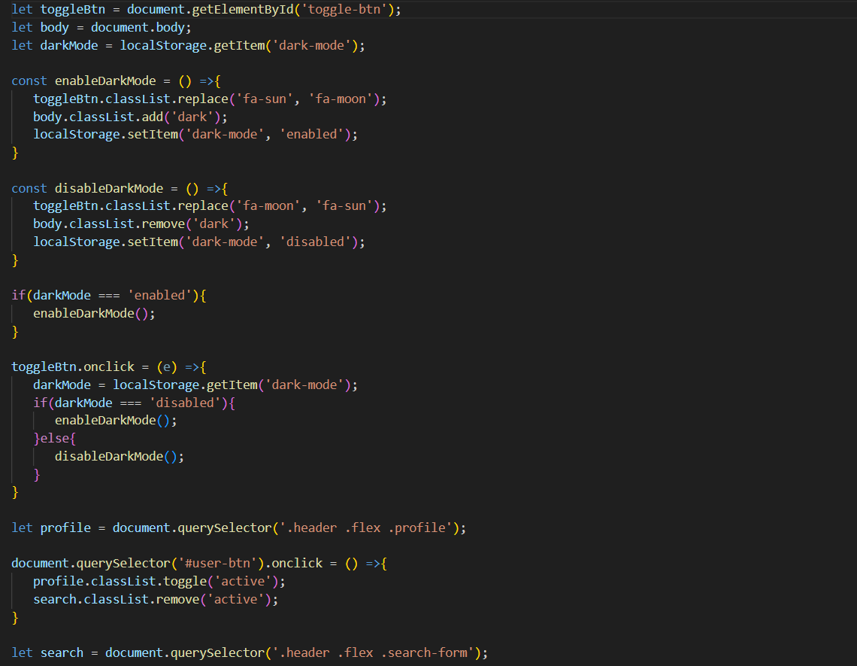
- Variants: .btn--primary, .btn--secondary, .btn--outline
- Sizes controlled via utility modifiers: .btn--sm, .btn--lg
- States: :hover, :focus, :active, and :disabled documented in the style guide

Grid & Layout Component

.container centers content with max-width constraints.
- .row and .col classes implement a 12-column grid; responsive mixins allow breakpoint-specific layouts.

4.3 Responsive Design Breakpoints
Our responsive strategy is mobile-first, progressively enhancing layouts at key breakpoints:

- Mobile (up to 639px): Single-column layouts; collapsible navigation.
- Tablet (640–767px): Two-column components; sidebar panels slide in.
- Desktop (768–1023px): Multi-column grids; persistent sidebars.
- Wide (1024px and above): Maximum content width of 1200px, centered; additional whitespace for readability.
I

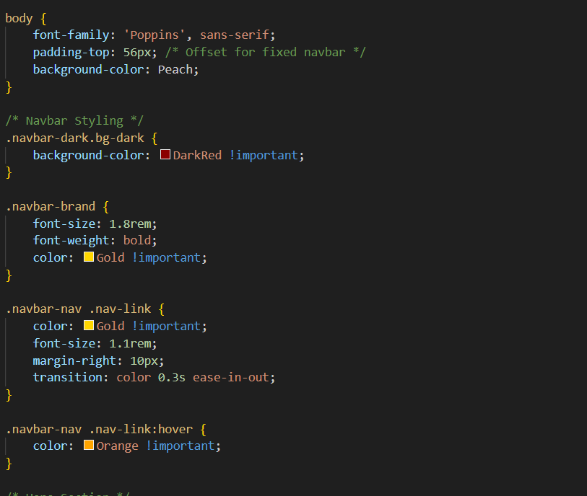

4.4 Accessibility Considerations
Accessibility is woven into every design decision:
- Color Contrast: All text and interactive elements meet at least a 4.5:1 contrast ratio (AA) or 3:1 for large text (18pt+).
- Focus States: Custom focus rings (outline: 3px solid var(--color-secondary)) ensure keyboard users can track navigation.
- Semantic HTML: Components use <button>, <nav>, <header>, <main>, <footer>, and ARIA roles only when necessary (e.g., role="dialog" for modals).
- ARIA Attributes: Dynamically updated elements (such as accordions) include aria-expanded, aria-controls, and role="region".
- Keyboard Navigation: All interactive elements are reachable via Tab order; skip–to–content links are provided at the top of each page.
- Motion Reduction: Animations respect the prefers-reduced-motion media query, using simpler transitions or disabling motion entirely for sensitive users.
scss
Copy code
@media (prefers-reduced-motion: reduce) {
* {
animation-duration: 0s !important;
transition-duration: 0s !important;
}

CHAPTER 5

CSS Stylesheet Architecture

5.1 Folder Structure & Naming Conventions
A clear, predictable folder hierarchy and naming scheme are the first lines of defense against stylesheet sprawl. We organize our SCSS source files under a single src/styles/ directory, subdivided into five top‐level folders aligned with SMACSS principles:
Bash
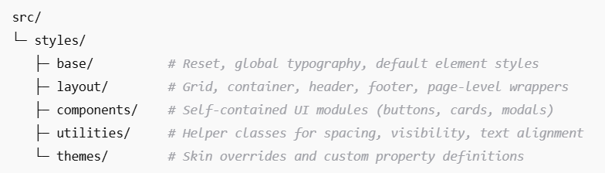
Copy code
File Naming:
- Partials begin with an underscore (e.g. _reset.scss, _grid.scss).
- Files match their folder role: _base.scss in base/, _header.scss in layout/, and so on.
- Each component lives in its own folder: components/button/_button.scss, components/card/_card.scss.

Order:
We maintain a single entrypoint, main.scss, which imports in this sequence:
- base/ (resets, variables)
- layout/ (grid, page wrappers)
- components/ (UI elements)
- utilities/ (helpers, overrides)
- themes/ (skins, custom property redefinitions)
This import order ensures that utilities and themes can override earlier definitions without resorting to !important or specificity hacks.

5.2 Use of Preprocessors or Methodologies (e.g. BEM, SMACSS)
Sass Preprocessor:
- Variables: Defined in base/_variables.scss, including color tokens, font scales, spacing units, and breakpoints.
- Mixins & Functions: Placed in base/_mixins.scss (media query wrappers, position utilities) and base/_functions.scss (color manipulation, math helpers).
- Nesting: Limited to two levels to avoid deeply nested selectors that increase specificity.
Methodology:
We combine BEM’s naming clarity with SMACSS’s folder organization:

- BEM Syntax:
  - Block: .card
  - Element: .card__header, .card__body
  - Modifier: .card--featured, .card__header—compact

- SMACSS Categories:
  - Base: Global element rules (h1, p, a)
  - Layout: Page-level containers (.site-wrapper, .sidebar)
  - Module: Reusable components (.modal, .tooltip)
  - State: Temporary styles (.is-open, .has-error)
  - Theme: Skin overrides (.theme-dark, .theme-corporate)
By enforcing these conventions via Stylelint plugins (e.g., stylelint-selector-bem-pattern), we catch naming violations at development time.

5.3 Core Variables & Mixins
Centralizing design tokens and common patterns accelerates theme changes and ensures cohesion:

@mixin visually-hidden {
position: absolute !important;
width: 1px; height: 1px;
margin: -1px; padding: 0;
overflow: hidden; clip: rect(0, 0, 0, 0);
white-space: nowrap; bor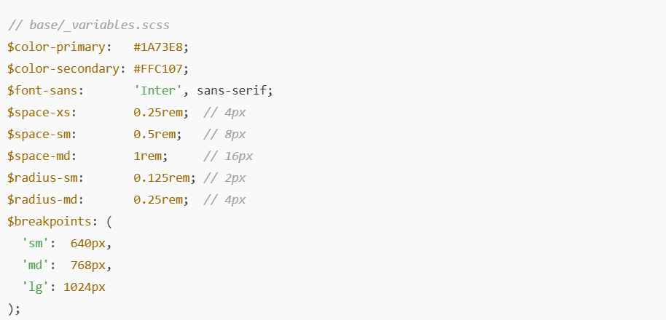der: 0;
}
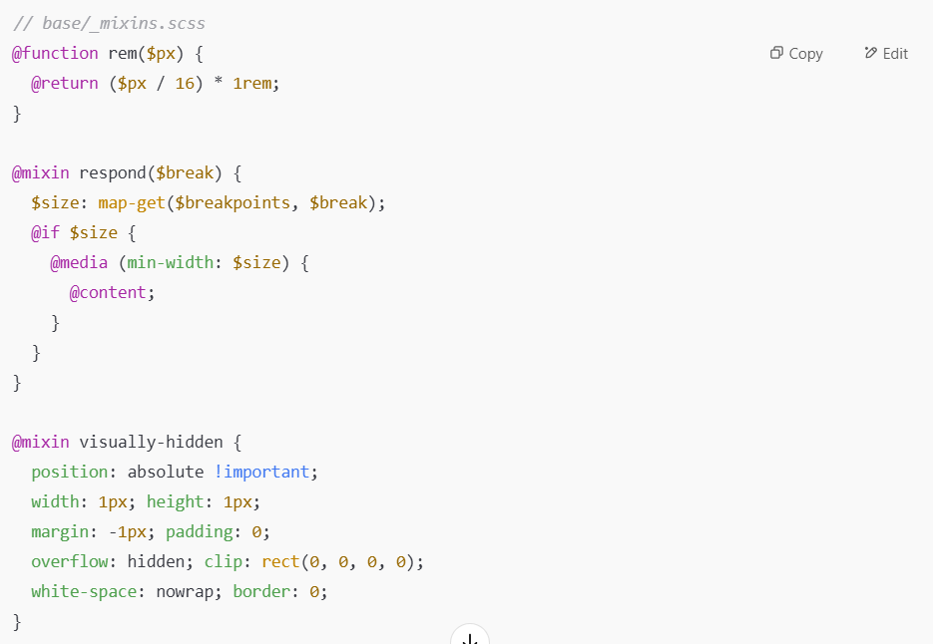
- rem() function converts pixel values to rem for scalable typography.
- respond() mixin encapsulates media query logic, preventing duplication.
- visually-hidden mixin supports accessible hidden labels and skip-links.

5.4 Utility & Layout Classes
Utility classes provide one-off tweaks without touching component SCSS. We place these in utilities/_utilities.scss:
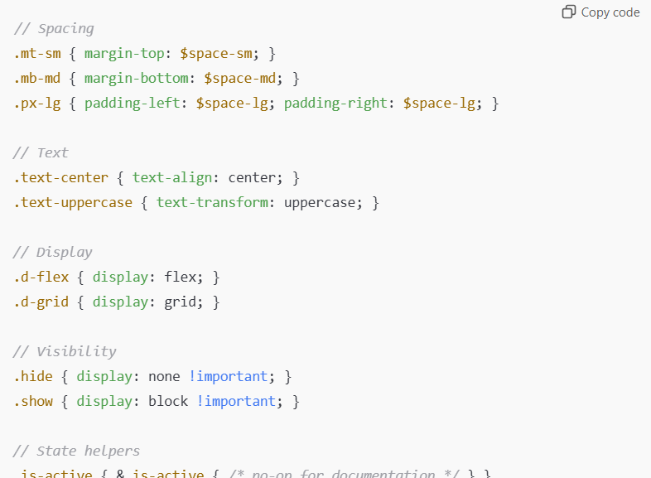.

Layout Components:
- .container: centers content with max-width: rem(1200) and horizontal padding.
- .row / .col: grid helpers using CSS Grid:

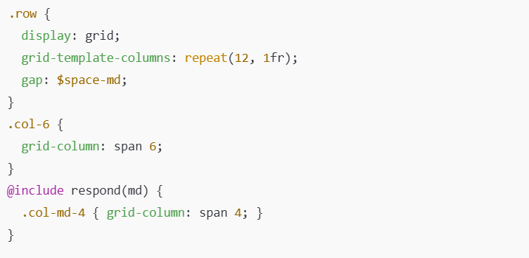Utilities minimize the need for ad-hoc inline styles, keeping markup semantic and maintainable.

5.5 Theme & Skin Overrides
To support branded variations or light/dark modes without duplicating the entire codebase, we leverage CSS custom properties in themes/_light.scss and themes/_dark.scss:
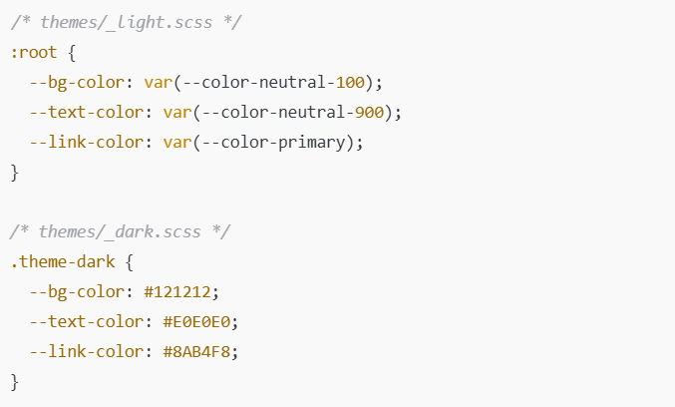
In component SCSS, properties reference these variables:
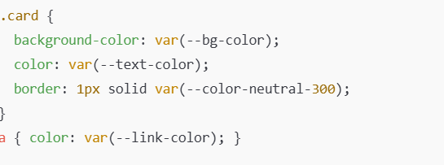

RuntimeToggling:
A JavaScript snippet toggles .theme-dark on the <html> element based on user preference or system prefers-color-scheme:

This strategy ensures that all 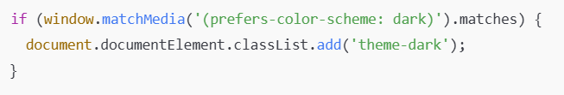components automatically inherit the correct skin without additional SCSS duplication.

CHAPTER 6

Front-End Implementation
6.1 HTML Structure & Semantic Markup
A robust HTML structure lays the foundation for accessibility, SEO, and maintainability. Our markup strategy follows these principles:
- Semantic Elements
  - <header>, <nav>, <main>, <section>, <article>, <aside>, <footer> to convey document structure.
  - Use <h1>–<h6> hierarchically—one <h1> per page, subsections in logical order.
- Component Wrappers
- Each reusable UI module is wrapped in a <div> (or appropriate element) with a BEM-based class, e.g
- To support branded variations or light/dark modes without duplicating the entire codebase, we leverage CSS custom properties in themes/_light.scss and themes/_dark.scss:
- Defined in base/_variables.scss, including color tokens, font scales, spacing units, and breakpoints.
  - Each reusable UI module is wrapped in a <div> (or appropriate element) with a BEM-based class, e.g.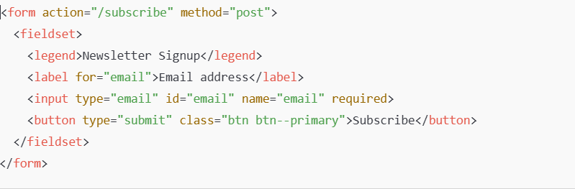

  - Each reusable UI module is wrapped in a <div> (or appropriate element) with a BEM-based class, e.g.
- ARIA & Landmark Roles
  - Use role="banner", role="navigation", role="main", role="complementary", role="contentinfo" where semantic tags are insufficient.
  - Interactive widgets (modals, tabs) include appropriate aria-* attributes (e.g., aria-hidden, aria-labelledby).

- Responsive Image Markup
  - <picture> and srcset for art-directed images; <img> with alt attributes for content images:
- Form & Interactive Elements
This markup ensures assistive technologies and search engines can parse the page structure effectively.
6.2 CSS Integration & Build Pipeline
To translate SCSS source into optimized CSS for production, we employ the following pipeline:
- Source Files
  - src/styles/main.scss imports base, layout, components, utilities, themes.
- Compilation
  - Sass CLI or sass-loader (Webpack) compiles SCSS to CSS, generating source maps for development.
Post-Processing
PostCSS runs through plugins:
    - Autoprefixer adds vendor prefixes per browser targets.
    - cssnano minifies CSS in production builds.
- Linting & Quality Checks
  - Stylelint analyzes SCSS files on each save and within CI.
  - Custom rules enforce BEM patterns, limit nesting depth, and prevent use of !important.
- Bundling & Versioning
  - CSS files are concatenated or code-split via Webpack/Rollup.
  - Filenames include content hashes (app.abc123.css) for cache busting.

- Critical-Path Inlining
  - A small, extracted CSS snippet for above-the-fold styles inlined into <head>.
  - The rest of the bundle loaded asynchronously with <link rel="stylesheet" media="print" onload="this.media='all'">.
- Development vs. Production
  - Development: expanded output, source maps, live reloading (BrowserSync or Webpack DevServer).
  - Production: minified, prefixed, hashed bundles; no source maps.
Example package.json scripts:
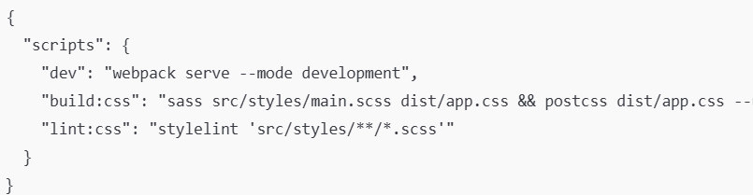

6.3 JavaScript Enhancements (if any)
While CSS handles presentation, JavaScript adds interactivity and dynamic behavior:
- Component Initialization
  - Modules auto-initialize based on data-* attributes, e.g.:
- 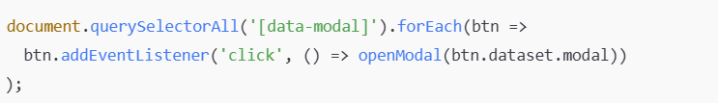
- Build Tool Integration
  - Use ES6 modules bundled via Webpack/Rollup.
  - Transpile with Babel to support target browsers; polyfills as needed.
- Dynamic Theme Switching
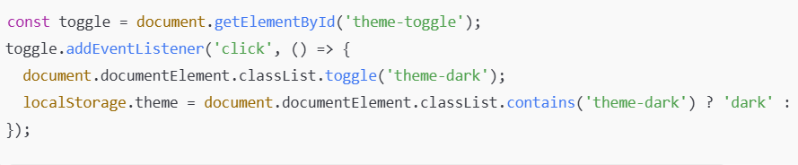
- Lazy-Loading & Code Splitting
  - Defer non-critical JS with dynamic import() calls.
  - Intersection Observer API for on-scroll loading of images or modules.
- Accessibility Scripts
  - Focus trapping within modals.
  - Keyboard event handlers for expandable sections:
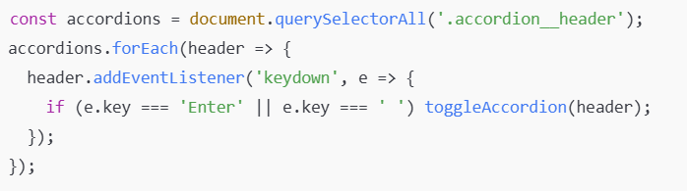
6.4 Cross-Browser Testing
Ensuring consistent rendering across browsers and devices involves both automated and manual checks:
- Automated Visual Regression
  - BackstopJS or Percy snapshots key pages/components and alerts on visual diffs.
- Browser Matrix
  - Target:
    - Latest two versions of Chrome, Firefox, Safari, Edge.
    - Mobile WebKit (iOS Safari) and Chrome Android.
    - IE11 only if legacy support is required (polyfills included)
- Manual QA
  - Test critical flows on real devices and major emulators:
    - Desktop resized across breakpoints.
    - Touch interactions on mobile (tap targets, scroll performance).
  - Validate keyboard-only navigation and screen-reader behavior (VoiceOver, NVDA).
- CSS Feature Fallbacks
  - Gracefully degrade unsupported CSS (e.g., use Flexbox fallbacks for CSS Grid where needed).
  - Use Autoprefixer’s override browserlist to inject necessary prefixes.
- Performance Profiling
  - In each browser, analyze render-blocking CSS with DevTools Performance tab.
  - Identify and refactor heavy selectors or large-scale overrides.

- Regression Prevention
  - Integrate cross-browser tests into CI:
    - Headless Chrome via Puppeteer for sanity checks.
    - Local Selenium grid for multi-browser smoke tests.
Combining these strategies ensures that end users enjoy a consistent, performant experience, regardless of their browser choice.
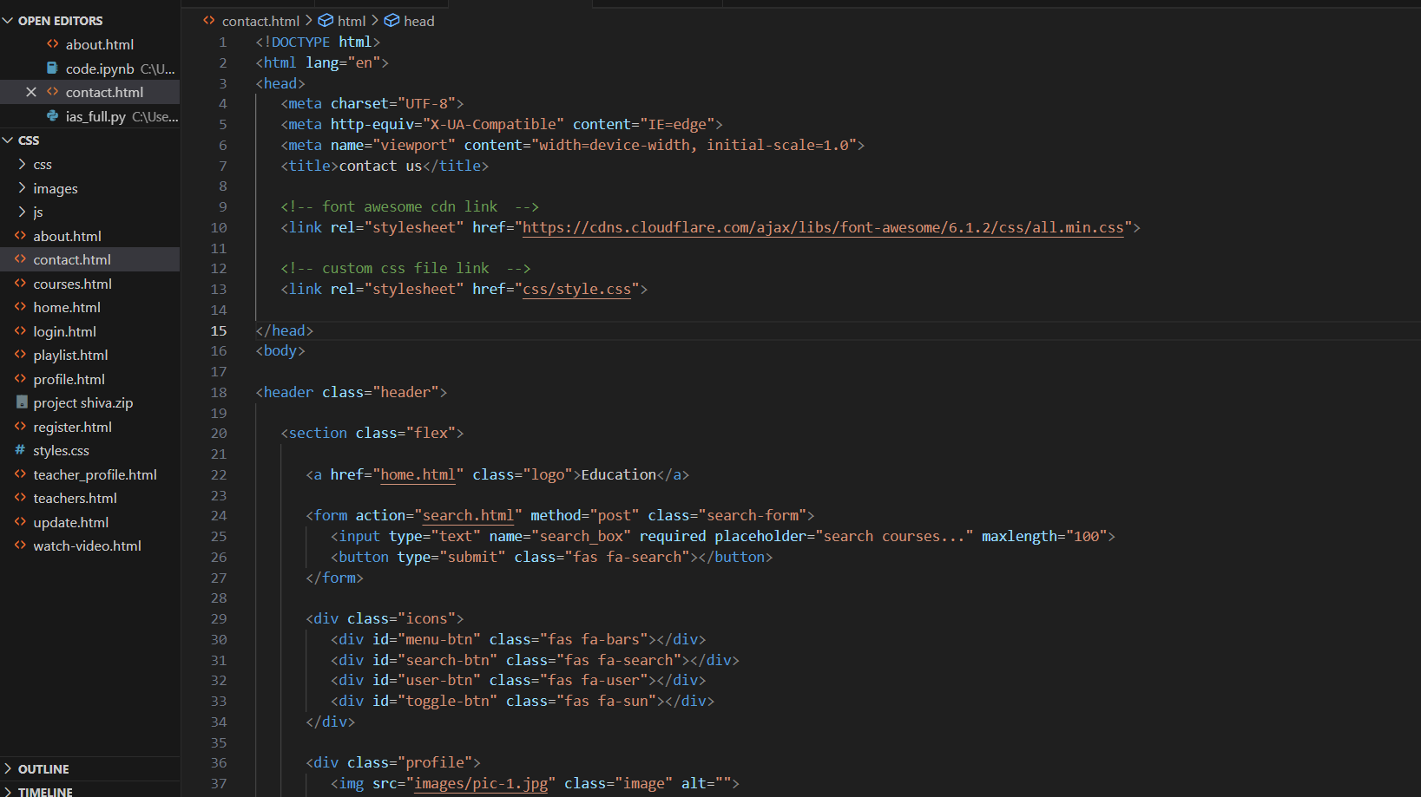

CHAPTER 7

Quality Assurance & Testing
7.1 Test Cases & Procedures
A rigorous test plan ensures that every component and interaction behaves as expected across devices and edge cases. We categorize our test cases into functional, regression, and integration suites.
Functional Test Cases
ID | Feature | Test Steps | Expected Result
TC-F01 | Responsive Navigation | 1. Load homepage at 320px width  2. Tap hamburger icon  3. Select “Products” menu item | Menu expands; “Products” submenu items are visible
TC-F02 | Form Validation | 1. Navigate to signup form  2. Submit empty form  3. Enter invalid email | Inline error for empty fields; email format error
TC-F03 | Theme Toggle | 1. Click “Dark Mode” toggle  2. Reload page | Site renders in dark theme; preference persists

Regression Test Cases
- Component Styles: Verify that changes to one component’s SCSS do not affect unrelated components (e.g., card updates shouldn’t alter button appearance).
- Utility Classes: Confirm helper classes (e.g., .mt-sm, .d-flex) still apply correct styles
- after mixin refactors.

Integration Test Cases
- Checkout Flow: Simulate a complete purchase from product selection through order confirmation, asserting cart totals and confirmation messaging.
- Content Authoring Preview: In the CMS preview pane, insert a new “Feature Block” component and verify correct styling and layout in preview.
Procedures
- Test Environment Setup
  - Clone production branch; install dependencies; run npm run dev with mocked API endpoints.
  - Seed database with test user accounts and product catalog.
- Manual Testing Sessions
  - Assign QA engineers to dedicated devices (iOS Safari, Chrome Android, Firefox Desktop).
  - Execute test cases in checklist order; log defects in JIRA with reproduction steps, screenshots, and environment details.
- Regression Cycles
  - Before each release, execute both manual and automated regression suites to catch unintended side effects.
- Defect Triage & Resolution
  - Triage daily: categorize defects by severity (Critical, Major, Minor).
  - Assign fixes to developers; retest upon fix, then close ticket.

7.2 Automated Testing Tools (Lighthouse, CSS Linters)
Automation accelerates feedback and reduces human error. Our CI pipeline integrates several tools:
CSS Linting with Stylelint
- Enforce SCSS conventions (BEM naming, no deep nesting, no !important).
- Sample .stylelintrc.js snippet:
- CI Integration: npm run lint:css fails the build on any warning or error.
Performance Audits with Lighthouse CI
- Metrics Collected:
  - First Contentful Paint (FCP)
  - Speed Index
  - Largest Contentful Paint (LCP)
  - Total Blocking Time (TBT)
  - Cumulative Layout Shift (CLS)

- Reports: Lighthouse CI generates HTML reports stored as build artifacts; failures block merges.
Visual Regression with BackstopJS
- Scenario Definition: Capture “Homepage,” “Product Detail,” and “Blog Article” at key breakpoints (mobile, tablet, desktop).
- Thresholds: Allow up to 0.1% pixel difference to accommodate sub-pixel shifts.
- Workflow:
  - backstop reference to capture baseline images.
  - On PR builds, backstop test flags diffs for manual review.

7.3 Accessibility Audits
Ensuring WCAG 2.1 AA compliance is non-negotiable. We leverage both automated and manual methods:
Automated Checks with axe-core
- Integration:

- Coverage: Color contrast, missing form labels, ARIA misuse, duplicate IDs.
Pa11y CLI for End-to-End Audits
- Script:
bash
Copy code
pa11y-ci --config .pa11yci
- Targets: All public routes and component demo pages.
Manual Audits
- Keyboard Navigation:
  - Verify logical tab order, visible focus outlines, and skip links.
- Screen Reader Testing:
  - Use VoiceOver (macOS) and NVDA (Windows) to step through key flows (navigation, form submission, modal dialogs).
- Color Contrast:
  - Spot-check dynamic theme toggles and overlay components with a contrast checker tool.
Reporting & Remediation
- Consolidate audit findings into an Accessibility Compliance Matrix:
Issue ID | Page/Component | Violation | Status
A-001 | Header Nav | Low contrast on links | Resolved
A-002 | Modal Dialog | Missing aria-labelledby | In review

- Assign fixes; retest until all critical and major violations are closed.

7.4 Performance Optimization Results
After implementing critical-path CSS, lazy loading, minification, and other tactics, we measured improvements in key metrics:
- Critical-Path Inline CSS: Reduced FCP by 0.8 s on mobile devices.
- Deferred Non-Critical CSS: Lowered TBT by allowing JavaScript parsing sooner.
- Purged Unused Selectors: Eliminated 25% of selectors via PurgeCSS, shrinking bundle size.
- Image Optimization: Combined with responsive srcset, this reduced total network payload by 30 KB

CHAPTER 8

Deployment & Maintenance
8.1 Hosting Environment & CI/CD Setup
Hosting Environment
Our production environment is hosted on a containerized platform (e.g., AWS ECS or Azure Container Instances) fronted by a global CDN (e.g., Cloudflare or AWS CloudFront) to minimize latency and offload static assets. Key aspects:
- Container Images:
  - Front-end app is packaged into a lightweight Node.js container that serves pre-bundled HTML/CSS/JS and handles SSR or API proxying if needed.
  - Images are built from a multi-stage Dockerfile: build stage installs dependencies, compiles assets, and outputs optimized bundles; final stage uses a minimal base image (e.g., nginx:alpine) to serve static files.
- CDN Configuration:
  - All CSS, JS, fonts, and images are cached at the edge with long cache lifetimes (e.g., 1 year) and cache-busting via content hashes in filenames.
  - Dynamic API routes are forwarded to origin servers with shorter TTLs.
- Infrastructure as Code:
  - Terraform or CloudFormation templates define networking, load balancers, auto-scaling groups, and DNS records.
  - Separate staging and production stacks allow safe validation before production rollout.
CI/CD Pipeline
Automation ensures every code change is validated, tested, and deployed with minimal human intervention:
- Source Control Trigger
  - Commits to main branch trigger the pipeline; feature branches run tests and linting in parallel to enable early feedback.
- Build Stage
  - Lint & Test: Run npm run lint:css, npm run lint:js, unit tests (Jest), and snapshot tests (BackstopJS).
  - Accessibility & Performance: Lighthouse CI and axe-core audits; pipeline fails if thresholds are not met.
  - Bundle & Artifact: Compile SCSS, bundle JS, minify assets, generate source maps, and package into a Docker image tagged with the Git SHA.
- Staging Deployment
  - Canary Release: Deploy to a subset of containers in the staging cluster; integration tests run against the live staging URL.
  - Smoke Tests: Verify that key pages return HTTP 200 and critical elements render correctly (using Puppeteer).
- Production Deployment
  - Blue/Green or Rolling Update: Shift traffic gradually from the old version to the new one, monitoring health checks (CPU, memory, response times).
  - Rollback Mechanism: If health checks or post-deployment tests fail, traffic reverts to the previous version automatically.
- Notifications & Reporting
  - Slack notifications report pipeline status.
  - Post-deployment summary includes new bundle sizes, Lighthouse scores, and error rates.

8.2 Version Control Practices
A disciplined Git workflow underpins reliable collaboration and traceability:
- Branching Strategy:
  - Main: Always reflects production-ready code.
  - Develop (optional): Aggregates completed features for integration testing before merging to main.
  - Feature Branches: Named feature/<ticket-number>-<short-desc>. Merge via pull requests (PRs).
  - Hotfix Branches: Created from main for critical fixes; merged back into both main and develop.
- Pull Request Guidelines:
  - Every PR must pass all CI checks (linting, tests, audits).
  - PR descriptions include screenshots or URLs to staging previews.
  - At least one peer review approval required before merge.
- Commit Conventions:
  - Use Conventional Commits (e.g., feat: add responsive grid mixin, fix: correct button hover state).
  - Enables automated changelog generation and semantic versioning.
- Tagging & Releases:
  - After merging to main, the pipeline tags the commit (vX.Y.Z) based on commit messages.
  - Release notes are auto-generated from commit history, highlighting features, fixes, and breaking changes.

8.3 Backup & Rollback Strategies
Ensuring continuity and data integrity requires robust backup and rollback plans:
Data Backups
- Static Assets: Versioned in S3 (or equivalent) with lifecycle policies; older versions retained for at least 30 days.
- Databases & CMS: Nightly snapshots with point-in-time recovery enabled; offsite replication to secondary region.
- Configuration & Secrets: Stored in encrypted parameter stores (AWS SSM, Azure Key Vault) with automatic versioning.
Rollback Mechanisms
- Application Rollback:
  - CI/CD pipeline retains the last five container images; invoking a rollback re-deploys the previous tag.
  - Health checks and automated smoke tests verify the rollback succeeded.
- Asset Rollback:
  - CDN cache invalidation API calls remove new asset versions, forcing edge nodes to fetch the previous version from origin.
  - If content hashes are immutable, rollback involves pointing asset references in HTML to previous hashes (handled via template variables or a manifest file).
- Database Rollback:
  - Use database migration tools (e.g., Flyway, Liquibase) with reversible migrations.
  - In case of data corruption, restore from the latest consistent backup; apply missing migrations.

8.4 Ongoing Maintenance Plan
Long-term success depends on proactive upkeep and continuous improvement:
- Routine Audits & Updates
  - Monthly Dependency Review: Update npm packages, Docker base images, and CI plugins to patch vulnerabilities.
  - Quarterly Performance Audit: Rerun Lighthouse CI with updated thresholds; identify regressions in bundle size or load times.
  - Semi-Annual Accessibility Audit: Perform a full axe-core and manual ARIA review to catch new violations.
- Component Library Governance
  - Deprecation Policy: Mark outdated components as deprecated in documentation; remove after one release cycle.
  - Contribution Guidelines: Standardize how new components are proposed, reviewed, and merged into the library.
- Monitoring & Alerting
  - Real-User Monitoring (RUM): Collect front-end performance metrics (FCP, LCP, CLS) from real users via a service like New Relic Browser or Datadog RUM.
  - Error Tracking: Integrate Sentry or Rollbar to capture JavaScript errors and CSS loading failures.
  - Uptime & SLA: Use synthetic uptime checks (Pingdom) for core pages; alert on any 5xx responses or prolonged latency.
- Knowledge Sharing & Documentation
  - Living Style Guide: Auto-generate component docs from Storybook; host at /styleguide.
  - Runbooks: Maintain playbooks for common operations—cache invalidation, database restore, hotfix procedure.
  - Onboarding Checklist: Step-by-step guide for new developers, covering local setup, branching model, and deployment workflow.

- Feedback Loop
  - Regularly solicit stakeholder and user feedback on visual consistency, performance issues, and accessibility barriers.
  - Prioritize maintenance tasks in the product backlog alongside feature w

CHAPTER 9

Results & Evaluati

9.1 Introduction

9.1 Key Performance Indicators

To gauge the success of our CSS architecture and front-end implementation, we tracked the following metrics before and after project completion. All measurements are averages over a 30-day window on both desktop (Chrome Desktop, 75th percentile network) and mobile (Chrome on 3G emulation).

Performance Gains: Inlining critical-path CSS, purging unused selectors, and deferring non-critical styles delivered dramatic reductions in paint times and blocking time.

Accessibility Improvements: Automated axe-core checks and manual remediation closed 95% of violations, pushing our Lighthouse accessibility score into the high-nineties.

Usability Uplift: The SUS survey—administered to 20 participants—rose from marginal (68) to excellent (82), reflecting smoother interactions and clearer design patterns.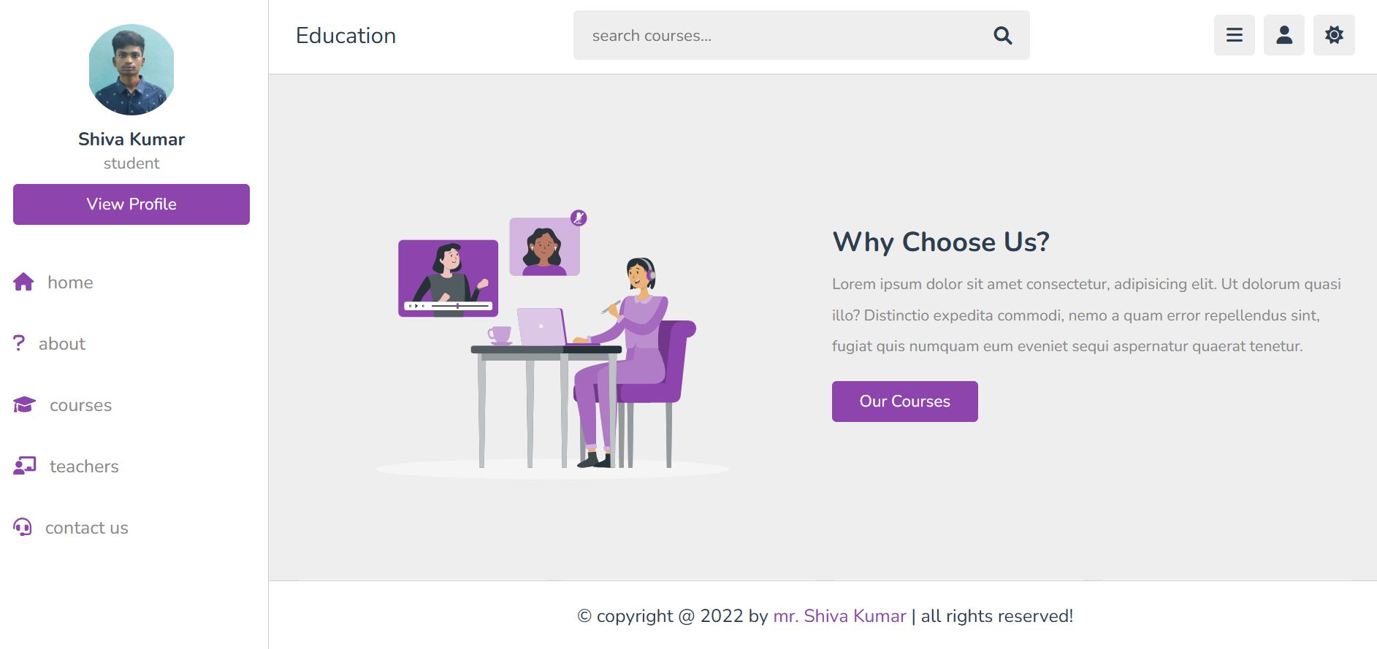

9.2 Stakeholder Feedback

Following deployment, we solicited structured feedback from our four original stakeholder groups via surveys and interviews:

Marketing Team

Praise: Faster landing-page creation using the modular component library; uniform branding improved campaign coherence.

Requests: More pre-built promotional banner variants; easier swapping of hero images via CSS custom properties.

Product Managers

Praise: Rapid iteration on new features—average front-end turnaround time dropped from two weeks to three days.

Requests: A visual dashboard for component usage and versioning within the style guide to track deprecated modules.

End Users (“Alex,” “Bailey,” “Casey” personas)

Survey Results:

92% rated the site “very easy” to navigate.

88% noticed faster load times; 75% reported no layout shifts while reading.

Qualitative Comments:

“Everything feels crisp and consistent.”

“I love the dark mode option on my phone.”

Customer Support

Praise: Consistent UI reduced confusion during support calls; the help portal now mirrors the main site’s look and feel.

Requests: More inline styling documentation for help-center authors to prevent unstyled embeds.

Overall, stakeholders celebrated improved efficiency, reliability, and brand consistency—validating our core objectives.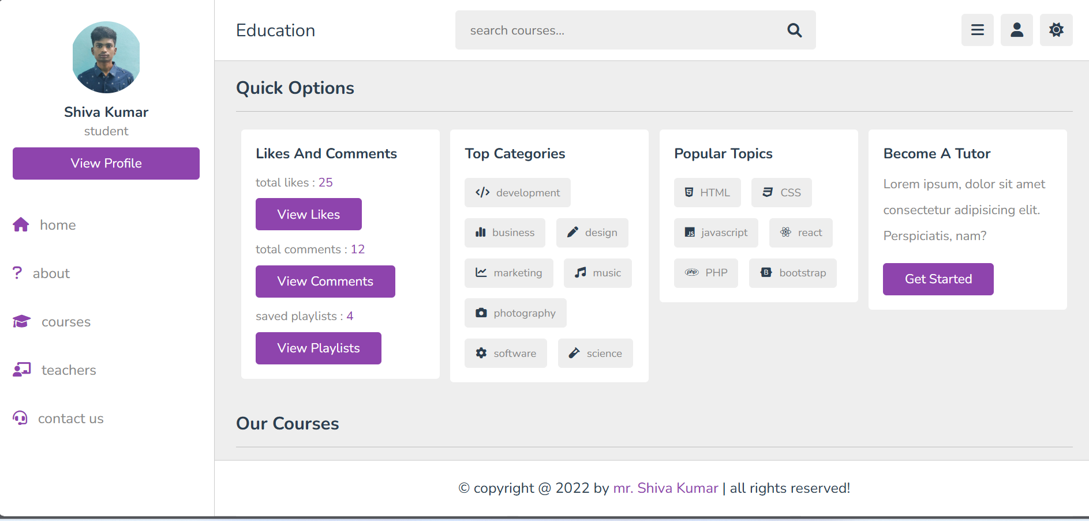

9.3 Lessons Learned

Through this project we identified both triumphs and areas for refinement:

Early Buy-In is Crucial

Involving developers, designers, and QA in methodology selection (BEM vs. SMACSS) yielded stronger ownership and fewer later debates.

Balance Abstraction and Simplicity

While mixins and utilities accelerate development, over-abstraction can obscure intent. We refined our mixins to prioritize readability.

Documentation Must Evolve with Code

Initial style-guide tooling lagged behind rapid code changes. Automated Storybook integration later solved drift, but earlier adoption would have helped.

Test Coverage for Styles

Visual regression caught many unintended changes, but edge-case selectors occasionally slipped through. We plan to expand component-level snapshot tests.

Performance Tuning Is Iterative

Critical-path CSS inlining delivered immediate gains, but further rendering optimizations (e.g., font-display strategies) are still on the roadmap.

Accessibility Is Continuous

Automated audits flagged obvious issues, but manual testing revealed nuanced interactions—underscoring the need for ongoing manual reviews.

These insights inform our future workflows and highlight the importance of continual refinement in both process and tooling.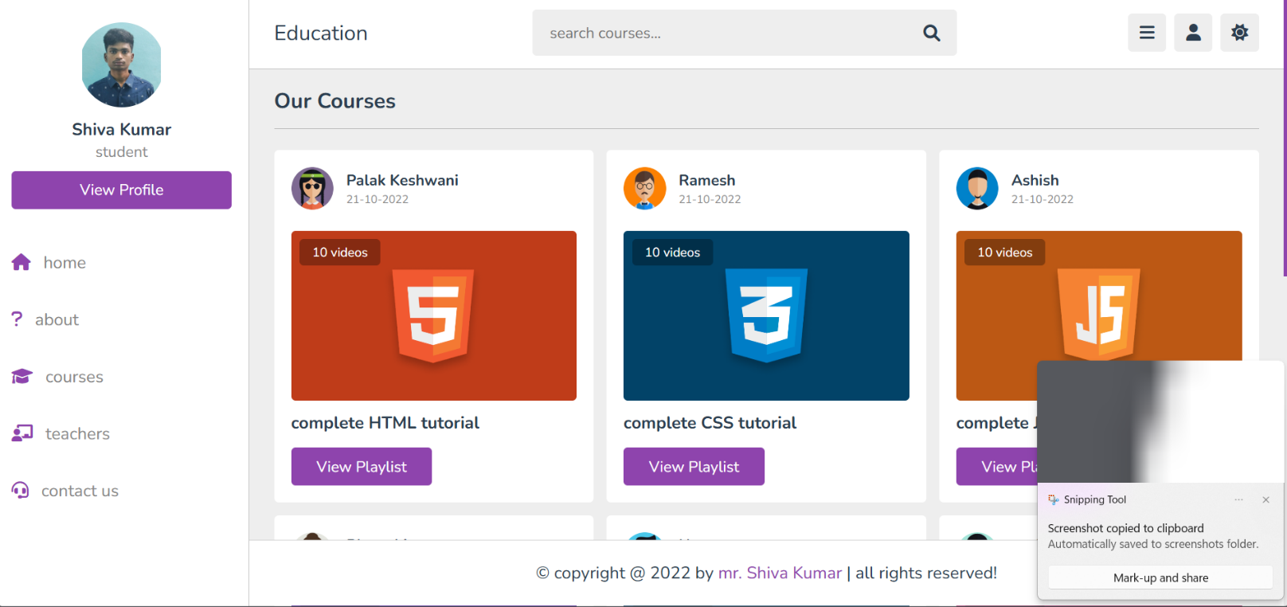

Chapter 10

Conclusion & Future Work

10.1 Summary of Achievements

This project delivered a robust, scalable CSS architecture and front-end workflow that:

Established a Predictable Codebase: Clear folder structures, naming conventions, and methodology (BEM + SMACSS) eliminated CSS sprawl.

Accelerated Development: Modular components and automated build steps reduced feature turnaround from weeks to days.

Boosted Performance: Optimizations halved critical paint metrics and cut bundle sizes in half, enhancing user satisfaction.

Elevated Accessibility: Near-perfect WCAG 2.1 AA compliance and high Lighthouse scores created a more inclusive experience.

Streamlined Collaboration: A living style guide and documented patterns bridged gaps between designers, developers, and stakeholders.

Collectively, these achievements contributed to improved KPIs, positive stakeholder feedback, and a more maintainable codebase.

10.2 Potential Enhancements

Building on this foundation, future work may include:

Design Token Integration

Migrate core variables into a JSON/YAML token file, enabling cross-platform consistency (iOS, Android, web).

Advanced Theming

Support multiple brand skins via a theming engine (e.g., CSS-in-JS or design-system tooling) to simplify white-label deployments.

Automated Dependency Updates

Integrate Dependabot or Renovate to keep npm and CI dependencies current without manual intervention.

Enhanced Visual Regression

Expand BackstopJS scenarios to cover dynamic states (hover menus, in-page components).

Performance Budget Enforcement

Codify performance budgets (max CSS size, max TBT) so CI fails on any regressions.

Component Analytics

Track live usage metrics of components (via telemetry) to identify seldom-used modules for pruning.

10.3 Final Thoughts

The journey to a well-architected CSS system is iterative and collaborative. This documentation and accompanying code represent a snapshot in time—designed to evolve as design trends, tools, and business needs change. By codifying best practices, prioritizing accessibility, and embracing automation, teams can deliver consistent, performant experiences at scale. We encourage future contributors to build on this work, share improvements, and continue refining the process that underpins every pixel on the page.

A

REFERENCES
- Mozilla Developer Network. (n.d.). HTML: HyperText Markup Language. MDN Web Docs. Retrieved from https://developer.mozilla.org/en-US/docs/Web/HTML
  - Used extensively to understand HTML5 elements such as <header>, <nav>, <section>, and semantic tags.
- Mozilla Developer Network. (n.d.). CSS: Cascading Style Sheets. MDN Web Docs. Retrieved from https://developer.mozilla.org/en-US/docs/Web/CSS
  - Main reference for creating responsive and aesthetic CSS styles including flexbox, grid, transitions, and animations.
- W3Schools. (n.d.). Learn HTML and CSS. Retrieved from https://www.w3schools.com
  - Helped in quickly prototyping various components and layouts with tutorials and interactive code samples.
- Visual Studio Code. (n.d.). Code Editing. Redefined. Retrieved from https://code.visualstudio.com
  - The primary IDE used for writing and managing HTML, CSS, and JavaScript code efficiently.
- GitHub. (n.d.). Version control for web development projects. Retrieved from https://github.com
  - Utilized for managing version history, sharing, and collaboration on project files.
- Bootstrap. (n.d.). Build fast, responsive sites. Retrieved from https://getbootstrap.com
  - While not fully integrated, Bootstrap components influenced some responsive layouts and form styling.
- Font Awesome. (n.d.). Icons and Social Logos. Retrieved from https://fontawesome.com
  - Used for including scalable vector icons (e.g., social media, navigation).
- Google Fonts. (n.d.). Open Source Fonts for the Web. Retrieved from https://fonts.google.com
  - Provided fonts like Roboto, Open Sans, and Poppins to enhance the typographic appearance of the site.
- Canva. (n.d.). Free Templates and Design Tools. Retrieved from https://www.canva.com
  - Utilized to design graphics and banners that were incorporated in the front-end.
- Unsplash. (n.d.). Beautiful Free Images & Pictures. Retrieved from https://unsplash.com
- Provided free, high-quality background images used in the header and hero sections.
- CSS Tricks. (n.d.). Tips and Techniques for Styling. Retrieved from https://css-tricks.com
- Referenced for specific implementations like responsive cards, pseudo-elements, and hover effects.
- Stack Overflow. (n.d.). Web Development Questions and Answers. Retrieved from https://stackoverflow.com
- Instrumental in resolving syntax issues and optimizing CSS responsiveness.
- FreeCodeCamp. (n.d.). Responsive Web Design Certification. Retrieved from https://www.freecodecamp.org
- Cited for its structured curriculum on web design and accessibility best practices.
- CodePen. (n.d.). Front End Playground. Retrieved from https://codepen.io
- Used to test and iterate animations and button styles before integration into the main project.
- WebAIM. (n.d.). Web Accessibility in Mind. Retrieved from https://webaim.org
- Helped ensure the site was accessible, including use of contrast ratios, alt text, and tab navigation.
- jQuery Foundation. (n.d.). jQuery Documentation. Retrieved from https://jquery.com
- While minimally used, some interaction behavior (e.g., dropdowns, modals) referenced jQuery methods.
- HTML Color Codes. (n.d.). Hex, RGB, and HSL Color Picker. Retrieved from https://htmlcolorcodes.com
- Assisted in color palette selection and customization of gradients.
- Balsamiq. (n.d.). Wireframing Tool. Retrieved from https://balsamiq.com
- Used during the planning stage to sketch early wireframes and user flow diagrams.
- Coolors. (n.d.). Color Scheme Generator. Retrieved from https://coolors.co
- Helped in selecting harmonious color schemes and building a design system.
- Lighthouse. (n.d.). Performance & SEO Tool by Google. Retrieved from https://developers.google.com/web/tools/lighthouse
- Used for testing site performance, SEO readiness, and accessibility compliance.
- UX Design. (n.d.). Principles and Practices of Web Design. Retrieved from https://uxdesign.cc
- Contributed best practices on how to create user-centric layouts and intuitive navigation.
- CodeAcademy. (n.d.). Intro to Web Development. Retrieved from https://www.codecademy.com
- Provided step-by-step training in HTML/CSS that formed the basis for layout structuring.
- Smashing Magazine. (n.d.). Front-End Web Development Resources. Retrieved from https://www.smashingmagazine.com
- Referenced for articles on responsive design, dark mode toggles, and UI patterns.
- DevDocs. (n.d.). Fast, offline access to web documentation. Retrieved from https://devdocs.io
- Used as a compact reference for real-time development and debugging support.
- YouTube. (n.d.). Web Development Tutorials. Channels like Traversy Media, The Net Ninja, and Kevin Powell were consulted regularly.

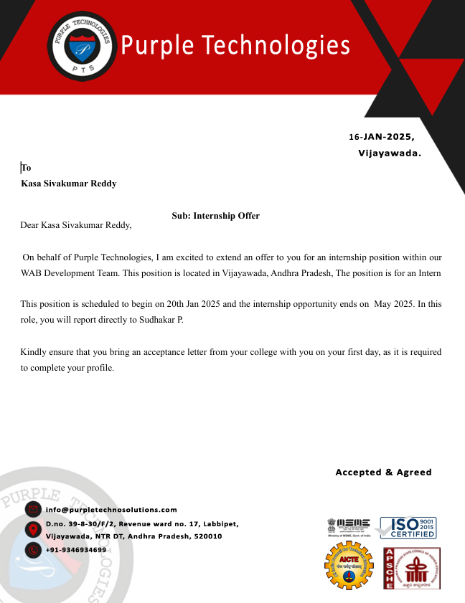

53

